**Acknowledgement**

We as a team produced a travelling website for our Publishing on World Wide Web final project. So as a build up idea , we choose Terengganu as our main point for this website task.

From beginning we collect all information from each of team member and then create a starting sketch of the website design and so continue to create this idea to a finished website.

**Project Title**

Country / Places Travel Log

* Terengganu , Malaysia

History

* formerly spelled Trengganu or Tringganu, is a sultanate and constitutive state of federal Malaysia. The state is also known by its Arabic honorific, Dāru l-Īmān ("Abode of Faith").
* Terengganu which stands at the mouth of the broad Terengganu River is both the state and royal capital as well as the largest city in Terengganu. There are many islands located close to the coast of Terengganu state, such as Redang Island.

Client

* We target everyone is our client, from children to adult.

Activities

1. Giving task to every team member and visiting so many website for research

Location

**Terengganu**

* Pulau Perhentian
* Pulau Kapas
* Pulau Lang Tengah
* Pulau Redang

**Project Profile**

Group Name : Reliquary Travelling

Project Member

* Zairul Fikri (Z)
* Raihan Rafiqi (R)
* Afiq Zufayri Khlifi (A)

Task

* Web Designer (R)
* Web Programmer (Z)
* Information researcher (A)
* Photographer (A)

**Goal and Objective**

Goals :

1. Becoming one of the big tourism websites
2. Training to develop skill in making website
3. Making a list of income
4. Promote this website to encourage people to visit Terengganu
5. Making each of a freelance website maker to improve income

Objective :

1. Using media social to employ our advertisement about our website
2. Using brochure or pamphlet to convey information in public
3. Show our website has more interesting with GUI and good design
4. Making our website is a user friendly type for all people comfort to use it
5. Provide the most accurate information about the place than another website

**Target Audience**

Our primary target is everyone like:

1. Children

- To make children attract to this website and invited their parents to visit the place.

2. Teenager

- For those that like to travel by their own or with friends.

3. Adult

- Maybe for jobs like photography for them to take photos at this place or maybe for them release their stress that make them choose this website to travel to the place.

Website content

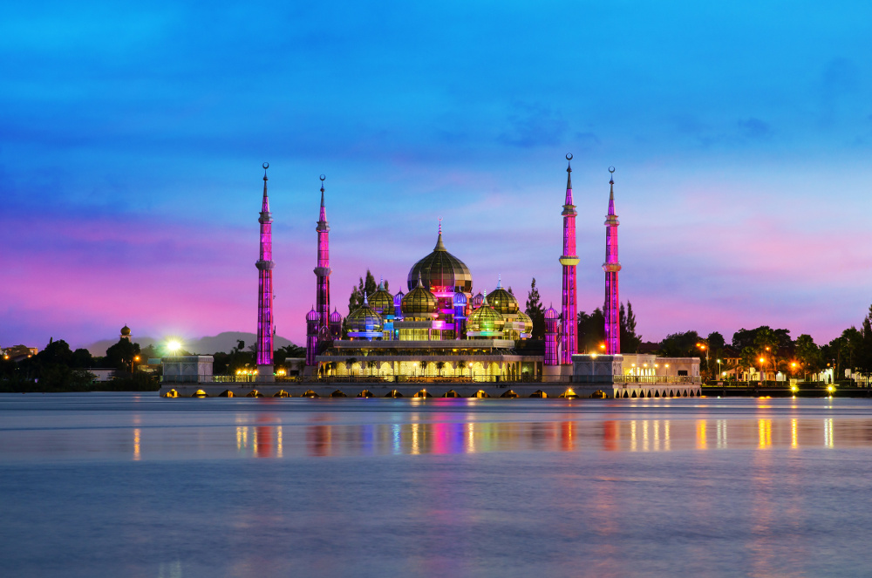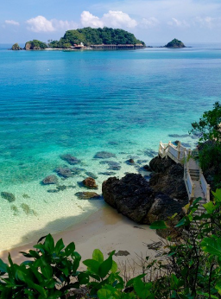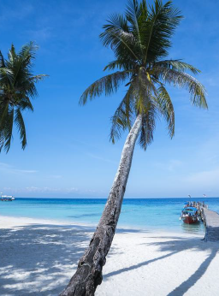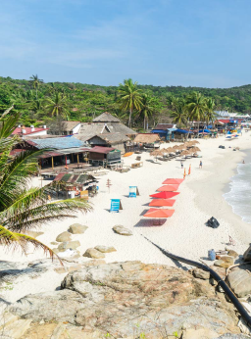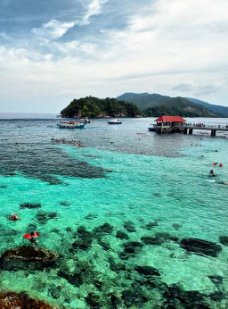

**Conclusion**

As a conclusion, We Reliquary Travelling want to say thank you to our lecturer for teaching us how to make website. We choose Terengganu to support the Visit Terengganu program and campaign, and so this will encourage people to visit this local Malaysia state.

Websites are playing important part in improvement of business.70% of the population is using dynamic and interactive websites because of their eye capturing visual effects. Static websites also have their own place for the platform where there is specific information required. Static websites require less investment as compare to dynamic websites.